IMPORT DATA USING TRANSFORM MAPS(SPREADSHEET)

1.Introduction:
Importing data is an important task in ServiceNow for transferring information from external sources, such as Excel or CSV files, into ServiceNow tables. Transform Maps are used to define how the imported data should be converted and mapped into the appropriate fields of a target table.
A Transform Map connects the Import Set Table containing the uploaded data with the Target Table where the final records will be stored. It uses field mappings, data transformations, and identification rules to ensure that the data is imported accurately and consistently.
Using Transform Maps helps automate the data import process, reduce manual data entry, maintain data quality, and efficiently migrate large amounts of information into ServiceNow.

Project Overview:

The project “Import Data Using Transform Maps in ServiceNow” focuses on importing data from an external spreadsheet, such as an Excel or CSV file, into ServiceNow. The project demonstrates how data can be loaded into an Import Set Table and then transformed and mapped into the required fields of a target ServiceNow table using Transform Maps.
The project includes creating an Import Set, configuring a Transform Map, defining field mappings, applying transformation rules, and validating the imported records. This process provides a structured and efficient way to migrate external data into ServiceNow while maintaining data accuracy and consistency.
Purpose of the Project:
The main purpose of this project is to understand and demonstrate the data import and transformation process in ServiceNow. It aims to:
- Import data from a spreadsheet into ServiceNow.
- Create and configure Import Set Tables.
- Create Transform Maps to connect source and target tables.
- Map source fields to the appropriate target fields.
- Apply transformation logic when required.
- Reduce manual data entry and improve efficiency.
- Ensure that imported data is accurate and properly organized.
- Verify and troubleshoot errors that occur during the transformation process.
Overall, the project provides practical knowledge of how Transform Maps can be used to automate and manage data migration in ServiceNow.
2. Ideation Phase
2.1 Problem Statement
Define the Problem Statements
Date | 28 September 2026
Team ID | __
Project Name | Import Data using Transform Maps (Spreadsheet)
Maximum Marks | 2 Marks
Customer Problem Statement Template:
The project focuses on the problem faced when employee information is received in spreadsheet format and needs to be imported into ServiceNow. Manual entry can take more time and repeated imports can create duplicate employee records. The solution uses Import Sets, Transform Maps and Coalesce to make the employee data import process accurate, efficient and reliable.
A clear problem statement helps identify the employee-data management challenge and supports the development of a suitable ServiceNow solution for importing, updating and validating employee records.
Example:
Proble m Stat ement  (PS) | I am  (Customer) | I’m trying to | But | Because | Which makes me feel
PS-1 | an HR/Admin user | import employee data from an Excel  spreadsheet into  ServiceNow | entering and transferring employee records manually can be time-consuming | the employee information is received in spreadsheet format and contains multiple records | concerned about time consumption and data-entry errors
PS-2 | an HR/Admin user | update existing employee records when new spreadsheet data is imported | repeated imports may create duplicate records | the same employee data may be imported more than once | concerned about duplicate and inconsistent employee records
Project Problem in simple words: Employee data from Excel needs to be imported into ServiceNow without manual effort, duplicate records or incorrect field mapping. The project addresses this using Import Sets, Transform Maps and Coalesce.

2.2 Empathy Map Canvas

Empathize & Discover
Date | 31 January 2025
Team ID | ____________________________
Project Name | Import Data using Transform Maps (Spreadsheet)
Maximum Marks | 4 Marks
Empathy Map Canvas:
The empathy map below represents the perspective of the main user of the ServiceNow employee data import process. It focuses on the user’s behaviour, expectations, challenges and goals while importing employee data from spreadsheets.
SAYS  “I need to import employee data from Excel into ServiceNow.” “I want the employee fields to be mapped correctly.”  “I do not want duplicate employee records.” | THINKS  “Will all spreadsheet records be imported correctly?” “How can I update existing employee records?”  “How can I verify that the import was successful?” | DOES  Prepares employee data in Excel. Loads the spreadsheet using Load Data / Import Set.  Creates and runs a Transform Map. Checks the Employee Test table and reports.
FEELS  Worried about manual data-entry errors.  Concerned about duplicate records. More confident when the import shows Success and the records can be validated. | PAINS  Manual entry takes time.  Incorrect field mapping can affect data quality.  Repeated imports may create duplicate records without Coalesce. Difficult to monitor large employee datasets manually. | GAINS  Faster employee data import. Accurate source-to-target field mapping.  Existing records can be updated using Coalesce.  Reports and Dashboard provide centralized visibility.
User: HR / Administrator who manages employee data in ServiceNow.

2.3 BrainStorming
Brainstorm & Idea Prioritization Template

Date | 28 September 2026
Team ID | ____________________________
Project Name | Import Data using Transform Maps (Spreadsheet)
Maximum Marks | 4 Marks
Brainstorm & Idea Prioritization Template:
The project focuses on importing structured employee data from an external spreadsheet into
ServiceNow using Import Sets and Transform Maps. The spreadsheet is loaded into an Import Set table, source fields are mapped to the Employee Test target table, and the transformed records are validated. Coalesce is used to avoid duplicate employee records, while Reports and Dashboards provide visibility into employee data and import activities.
Step-1: Team Gathering, Collaboration and Select the Problem Statement
Problem Statement: Employee information received in Excel format needs to be imported into ServiceNow accurately and efficiently. Repeated imports can also create duplicate records unless existing employees are identified and updated correctly.
Selected Project Idea: Build a ServiceNow-based employee data import process using Import Sets, Transform Maps and Coalesce, with Reports and Dashboards for monitoring.
Step-2: Brainstorm, Idea Listing and Grouping

No. | Brainstormed Idea | Group
1 | Import employee data from Excel into ServiceNow | Data Import
2 | Create a custom Employee Test table | Data Management
3 | Use Transform Map to map source and target fields | Transformation
4 | Enable Coalesce to prevent duplicate employee records | Data Integrity
5 | Update existing employee records when the same Employee ID is imported | Data Update
6 | Create department-wise employee reports | Reporting
7 | Create location-wise employee reports | Reporting
8 | Create an employee list report | Reporting
9 | Create an Employee Analytics Dashboard | Dashboard

3.Requirement Analysis
3.1 Customer Journey Map
CUSTOMER JOURNEY MAP
Date | 28 September 2026
Team ID | ________________________
Project Name | Import Data using Transform Maps
Maximum Marks | 4 Marks
SCENARIO
Importing structured employee data from an external spreadsheet into ServiceNow, transforming the data into the Employee Test table, validating the result, preventing duplicates with Coalesce, and reviewing the imported data through reports and a dashboard.
Journey Scope
This journey follows the documented project process from preparing the spreadsheet through data import, transformation, validation, duplicate handling, reporting and dashboard review.
3.2 Solution Requirement
Functional Requirements
The following functional requirements are derived from the Import Data using Transform Maps project. The solution imports structured employee data from a spreadsheet into ServiceNow, transforms it into the target table, prevents duplicate records, validates results, and provides reports/dashboard visibility.
FR No. | Functional Requirement (Epic) | Sub Requirement (Story / Sub-Task)
FR-1 | Prepare Employee Spreadsheet | Create spreadsheet with Employee ID, Employee Name, Email, Department and Location.
FR-2 | Create Employee Target Table | Create Employee Test table and configure required employee fields.
FR-3 | Create Import Set | Load the spreadsheet into the Employee Import staging/import table.
FR-4 | Configure Transform Map | Create Transform Map and select Employee Import as source and Employee Test as target.
FR-5 | Map Source and Target Fields | Use Auto Map Matching Fields / Mapping Assist to map spreadsheet fields to target fields.
FR-6 | Transform Employee Data | Execute the Transform Map and create/update employee records in the target table.
FR-7 | Prevent Duplicate Records | Enable Coalesce on a unique employee field such as Employee ID to update existing records instead of cr
FR-8 | Validate Import Results | Check transform status/history and verify inserted, updated, skipped/ignored records.
FR-9 | Generate Employee Reports | Create reports for employees by department, employees by location, and employee list.
FR-10 | Create Employee Dashboard | Add the reports to an Employee Analytics Dashboard for centralized monitoring.
Non-functional Requirements
NFR No. | Non-Functional Requirement | Description
NFR-1 | Usability | The import process and configuration should be easy to follow and operate through ServiceNow.
NFR-2 | Data Integrity | Imported employee data should be mapped correctly and verified after transformation.
NFR-3 | Reliability | The system should consistently complete valid imports and provide transform status/history for verification.
NFR-4 | Performance | Bulk spreadsheet data should be processed efficiently through Import Sets and Transform Maps.
NFR-5 | Availability | Imported employee records, reports and dashboard information should remain accessible to authorized use
NFR-6 | Scalability | The solution should support repeated employee data imports and increasing data volume without changing
Project Data Flow Summary
External Spreadsheet → Import Set / Employee Import → Transform Map → Field Mapping → Employee Test
Table → Validation / Transform History → Reports → Employee Analytics Dashboard
The project uses Import Sets as a staging area and Transform Maps to map source fields to the target Employee Test table. Coalesce is used to identify existing employee records and avoid duplicate insertion during repeated imports.
3.3 Data Flow Diagram
Data Flow Diagram (DFD)
The DFD represents how employee data moves through the ServiceNow import process. It shows the source spreadsheet, staging/import table, transformation process, target employee table, validation, reporting and dashboard output.
DFD Element | Data Flow / Process
External Entity | HR / Administrator provides employee spreadsheet data.
Process 1 – Load Data | Spreadsheet is uploaded through ServiceNow Load Data into the Employee Import staging table.
Data Store 1 – Employee Import | Stores imported spreadsheet records before transformation.
Process 2 – Transform Data | Transform Map maps source fields to the Employee Test target fields.
Process 3 – Coalesce / Update | Employee ID is used to identify existing records and update them instead of inserting duplicates.
Data Store 2 – Employee Test | Stores the transformed employee records.
Process 4 – Validate | Transform history and target records are checked for inserted, updated, skipped/ignored results.
Process 5 – Reporting | Employee data is used to create department, location and employee list reports.
Output – Dashboard | Reports are consolidated in the Employee Analytics Dashboard.
DFD Flow
HR / Administrator → Employee Spreadsheet → Load Data → Employee Import Table → Transform Map → Field
Mapping & Coalesce → Employee Test Table → Validation / Transform History → Reports → Employee Analytics
Dashboard
User Stories
Use the following template to list the user stories for the Import Data using Transform Maps project.
User Type | Functional Requirement | (Epic)User Story N | o. User Story / Task | Acceptance Criteria | Priority | Release
Administrator / HR | Prepare Employee Data | USN-1 | As an administrator, I can prepare employee | data in spreadsheet format so that it cSpreadsheet contains required empl | an be oyee fields High | and valid data.Sprint-1
Administrator / HR | Import Employee Data | USN-2 |  | As an administrator, I can upload the employee spreadsheet using Load Data so that records are loaded into the import table. | High | Sprint-1
ServiceNow Admi | nistCreate Target Tableator | USN-3 | As an administrator, I can create the Employ | ee Test table with the required employ | Employee ID, Name, Email, Department and Location fields are available.e High f elds. | Sprint-1
ServiceNow Admi | nistratorConfigure Transform M | apUSN-4 | As an administrator, I can create a Transfor | m Map between EmployeSource and target tables are selecte Import and | Employee Ted correctly.High | st.Sprint-1
ServiceNow Admi | nistratorMap Fields | USN-5 | As an administrator, I can map source sprea | dsheet fields to target employee fields.All required source fields are mapped to the correct target fields. | High | Sprint-1
ServiceNow Admi | nistratorTransform Data | USN-6 | As an administrator, I can run the Transform | Map so that imported data is created i | Transform completes successfully and target records are created/updated. the EmploHigh | yee TesSprint-1 table
ServiceNow Admi | nistPrevent Duplicatesator | USN-7 | As an administrator, I can enable Coalesce u | sing Employee ID so that repeated imExisting Employee IDs are updated and duplicate rows are not inserted. | ports do not High | createSprint-2
Administrator / HR | Validate Import | USN-8 | As an administrator, I can view transform hist | ory so that I can verify inserted, updatTransform history shows the processing result for uploaded rows. | ed and ignorHigh | ed records.Sprint-2
Administrator / HR | View Reports | USN-9 | As an administrator, I can view employee rep | orts by department, location and emplRequired reports display the corresponding employee information. | oyee list.Medium | Sprint-2
Administrator / HR | Monitor Dashboard | USN-10 | As an administrator, I can view employee an | alytics in a dashboard so that import aEmployee Analytics Dashboard contains the configured reports. | nd employeeMedium | Sprint-2

Project Outcome
The completed solution supports spreadsheet-based employee data import into ServiceNow through Import Sets and Transform Maps, uses Coalesce to manage repeated imports, validates transformation results, and provides reports and a centralized dashboard for employee data visibility.

4 Project Design
4.1 Problem Solution Fit
SECTION | CANVAS QUESTION | PROJECT-SPECIFIC ANSWER
1. CUSTOMER  SEGMENT(S) | Who is your customer? | HR teams, HR administrators and ServiceNow administrators who manage employee records.
2. JOBS-TO-BE-DONE  / PROBLEMS | Which jobs-to-be-done or problems do you address? | Import employee data from Excel into ServiceNow, update existing employee records and avoid duplicate records.
3. TRIGGERS | What triggers customers to act? | Receiving a new employee spreadsheet, bulk employee onboarding, employee information updates, or repeated data imports.
4. EMOTIONS:  BEFORE / AFTER | How do customers feel before and after? | Before: time-consuming, difficult and concerned about errors or duplicate records. After: faster, organized and easier employee data management.
5. AVAILABLE  SOLUTIONS | Which solutions are available when customers face the problem? | Manual data entry, copy-paste from Excel, and maintaining employee records manually. These require more effort and can lead to duplicate or inconsistent data.
6. CUSTOMER  CONSTRAINTS | What constraints limit the available solutions? | Large volume of employee data, limited time, manual effort, data accuracy requirements and  duplicate-record problems.
7. BEHAVIOUR | What does the customer do to address the problem? | Prepare Excel data → upload into ServiceNow → create/load import data → map fields → transform records → verify the result.
8. CHANNELS OF  BEHAVIOUR | 8.1 ONLINE | Excel/Google Spreadsheet, ServiceNow, Import Set, Transform Map, Reports and Dashboard.
8.2 OFFLINE | What offline actions are taken? | HR forms, employee records and manually maintained spreadsheets.
9. PROBLEM ROOT  CAUSE | What is the real reason this problem exists? | Employee information is maintained in external spreadsheets and must be transferred into  ServiceNow. Manual transfer creates extra work and can cause duplicate or inconsistent records.
10. YOUR SOLUTION | What is your solution? | Use ServiceNow Import Sets and Transform Maps to import and transform spreadsheet data. Use Coalesce to identify existing Employee IDs and prevent duplicate records. Use Reports and Dashboard for monitoring and visualization.
PROJECT FLOW: Excel Spreadsheet → Import Set → Transform Map → Field Mapping → Employee Test Table → Coalesce → Reports → Employee Analytics Dashboard
4.2 Proposed Solution
S.No. Parameter | Description
1. Problem Statement  (Problem to be solved) | Employee data is received in Excel/spreadsheet format and needs to be entered into ServiceNow. Manual data entry takes time and may cause duplicate or inconsistent employee records. A systematic way is required to import, update and validate employee data efficiently.
2. Idea / Solution description | The project uses ServiceNow Import Sets and Transform Maps to import employee data from a spreadsheet. The spreadsheet is loaded into an Import Set table, source fields are mapped to the Employee Test target table, and the data is transformed. Coalesce is enabled on Employee ID to identify existing records and avoid duplicate entries. Reports and an Employee Analytics Dashboard are created to monitor the imported employee data.
3. Novelty / Uniqueness | The solution combines spreadsheet data import, field mapping, automated transformation and Coalesce-based duplicate prevention in one ServiceNow workflow. Reports and a dashboard provide a centralized view of employee information after the import.
4. Social Impact / Customer  Satisfaction | The solution reduces manual data-entry effort for HR and ServiceNow administrators, helps maintain cleaner employee records and makes employee information easier to monitor through reports and dashboards. It can improve the user experience by making bulk employee data handling more organized.
5. Business Model  (Revenue Model) | This project is an internal enterprise data-management solution rather than a direct revenue-generating product. It can be used by organizations as part of their ServiceNow HR/data-management operations to reduce manual effort and improve data quality.
6. Scalability of the Solution | The same Import Set and Transform Map approach can be extended to larger employee datasets and additional fields. More reports, dashboards and data sources can be added as organizational requirements grow. Coalesce can continue to help identify existing records during repeated imports.
Project Flow: Spreadsheet → Import Set → Transform Map → Field Mapping → Employee Test Table → Coalesce →
Reports → Employee Analytics Dashboard
4.3 Solution Architecture
Project Name | ServiceNow Employee Data Import & Analytics
Platform | ServiceNow
Core Technologies / Features | Import Sets, Transform Maps, Coalesce, Reports, Dashboards
Primary Use Case | Bulk employee data import, update, duplicate prevention and reporting
Purpose: Provide a clear architecture showing how employee data moves from an external spreadsheet into ServiceNow, how records are transformed and de-duplicated, and how the resulting data is exposed through reports and a centralized dashboard.

1. Solution Overview
The project implements an employee data management solution in ServiceNow using Import Sets and Transform Maps. External spreadsheet data is first loaded into an Import Set staging table. A Transform Map maps source fields to the Employee Test target table, after which the transformation creates or updates records. Coalesce is used on Employee ID to prevent duplicate records during repeated imports. Reports and an Employee Analytics Dashboard provide visibility into the resulting data.

Business / Technical Problem
- Employee data is received in spreadsheet format and needs to be loaded into ServiceNow efficiently.
- Source fields must be mapped correctly to target employee fields.
- Repeated imports can create duplicate records unless an existing-record identifier is used.
- Administrators and HR users need a centralized view of employee data and trends.

Solution Objectives
- Create a controlled staging layer using an Import Set table.
- Map and transform spreadsheet fields into the Employee Test table.
- Use Coalesce with Employee ID to distinguish existing and new employee records.
- Validate inserted, updated and ignored records through Transform History.
- Provide Department, Location and Employee List reports and combine them in a dashboard.

2. Solution Architecture
Solution Architecture & Data Flow
External Excel
Employee data
Spreadsheet
Import Set Table
Staging area
Employee Import
Transform Map
Field mapping
Auto Map / Assist
Employee Test
Target table
u_employee_test
Coalesce
Employee ID identifies
existing records
Result
New
→
Insert
Existing
→
Update
Same
→
Ignore
Reports
Department • Location
Employee List
Dashboard
Employee Analytics
Central view
Flow based on the uploaded ServiceNow Import Sets / Transform Maps project.
The architecture follows the project’s documented flow: external Excel → Import Set staging → Transform Map → Employee Test target table → Reports → Dashboard. Coalesce operates during transformation to identify existing records and avoid duplicates.

3. Architecture Components
Component | Role in the solution
External Excel Spreadsheet | Source of structured employee data received for bulk import.
Employee Import (Import Set  Table) | Temporary/staging area where source data is loaded before transformation.
Sample Spreadsheet Import  (Transform Map) | Defines the source-to-target mapping and performs the transformation.
Employee Test (u_employee_test) | Custom target table containing Employee ID, Employee Name, Email, Department and Location.
Coalesce / Employee ID | Identifies existing employee records so repeated imports update rather than create duplicates.
Transform History | Shows import outcomes such as inserted, updated and ignored records.
Reports | Department-wise, location-wise and employee list views.
Employee Analytics Dashboard | Centralized visual view of the employee reports.

4. End-to-End Data Flow
- Prepare source data — Create the employee spreadsheet and save it as an Excel file.
- Load data — Load the spreadsheet into the Employee Import Import Set table.
- Transform — Use the Sample Spreadsheet Import Transform Map to map source fields to Employee Test.
- Identify records — Coalesce on Employee ID identifies whether an employee already exists.
- Apply result — New IDs are inserted; existing IDs with changed values are updated; repeated unchanged rows can be ignored.
- Validate — Review Transform History and the Employee Test table.
- Report — Create Employees by Department, Employees by Location and Employee List reports.
- Dashboard — Add the reports to Employee Analytics Dashboard for centralized monitoring.

5. Data Mapping
Source / Employee data | Target: Employee Test
Employee ID | Employee ID
Employee Name | Employee Name
Email | Email
Department | Department
Location | Location

6. Duplicate Prevention & Update Logic
The project enables Coalesce on a field map so that Employee ID is used to identify an existing record. The documented test demonstrates that when four rows are imported, two new employee IDs are inserted and two existing employee IDs are updated when their name/email values change. Re-uploading the same unchanged sheet results in ignored rows rather than duplicate records.
Condition | Documented transformation outcome
Employee ID does not exist | Insert new employee record
Employee ID exists and values changed | Update existing employee record
Same data imported again | Ignore unchanged rows

7. Reporting & Dashboard Architecture
- Employees by Department — Pie chart, grouped by Department, aggregation Count.
- Employees by Location — Bar chart, grouped by Location, aggregation Count.
- Employee List Report — List containing Employee ID, Employee Name, Email, Department and Location.
- Employee Analytics Dashboard — consolidates the three reports into one centralized view.

8. Expected / Documented Solution Outcome
- Employee records are imported from Excel into ServiceNow through a controlled Import Set and Transform Mapflow.
- Source fields are mapped to the custom Employee Test table.
- Coalesce reduces duplicate creation during repeated imports and supports updates to existing records.
- Transform History provides visibility into the import results.
- Reports and a dashboard provide centralized visibility into employee data.

9. Architecture Summary
This solution bridges the business requirement of efficient employee-data migration with ServiceNow platform capabilities. The architecture separates staging, transformation, target storage and reporting, while Coalesce adds a record-matching mechanism for repeated imports. The resulting reports and dashboard provide a single place for administrators and HR teams to view employee information.

5 Project Planning & Sheduling
5.1 Project Planning
Product Backlog, Sprint Schedule, and Estimation (4 Marks)
The backlog below is adapted to the ServiceNow employee-data import project described in the project document.
Sprint | Functional Requirement  (Epic) | User Story  Number | User Story / Task | Story  Points | Priority
Sprint-1 | Data Preparation &  Employee Table | USN-1 | As an admin, I can prepare the employee spreadsheet with sample employee data for import. | 3 | High
Sprint-1 | Data Preparation &  Employee Table | USN-2 | As an admin, I can create the Employee Test custom table in ServiceNow. | 3 | High
Sprint-1 | Data Preparation &  Employee Table | USN-3 | As an admin, I can configure Employee ID, Employee Name, Email, Department and Location fields. | 2 | High
Sprint-2 | Import Set & Transform  Map | USN-4 | As an admin, I can create the Employee Import Import Set table and load spreadsheet data. | 3 | High
Sprint-2 | Import Set & Transform  Map | USN-5 | As an admin, I can create a Transform Map connecting Employee Import to Employee Test. | 2 | High
Sprint-2 | Import Set & Transform  Map | USN-6 | As an admin, I can map source and target fields and execute the transform successfully. | 2 | High
Sprint-3 | Coalesce & Validation | USN-7 | As an admin, I can enable Coalesce on Employee ID to prevent duplicate records. | 2 | High
Sprint-3 | Coalesce & Validation | USN-8 | As an admin, I can import changed and new employee records and verify inserts and updates. | 2 | High
Sprint-3 | Coalesce & Validation | USN-9 | As an admin, I can review Transform History and verify ignored duplicate rows. | 2 | Medium
Sprint-4 | Reports & Dashboard | USN-10 | As an admin, I can create an Employees by Department report. | 2 | Medium
Sprint-4 | Reports & Dashboard | USN-11 | As an admin, I can create an Employees by Location report and Employee List report. | 2 | Medium
Sprint-4 | Reports & Dashboard | USN-12 | As an admin, I can create the Employee Analytics Dashboard and add the reports. | 2 | High
Sprint-4 | Reports & Dashboard | USN-13 | As an admin, I can validate the final employee data, reports and dashboard. | 2 | Medium
Total planned story points: 29
Project Tracker, Velocity & Burndown Chart (4 Marks)
Sprint | Total Story  Points | Duration | Sprint Focus | Planned Story Points  Completed | Sprint Release / Review
Sprint-1 | 8 | 6 Days | Spreadsheet, custom table and fields | 8 | End of Sprint-1
Sprint-2 | 7 | 6 Days | Import Set, Transform Map and field mapping | 7 | End of Sprint-2
Sprint-3 | 6 | 6 Days | Coalesce, new imports, updates and validation | 6 | End of Sprint-3
Sprint-4 | 8 | 6 Days | Reports, dashboard and final validation | 8 | End of Sprint-4
Velocity
Total planned work = 29 story points across 4 sprints. Average velocity = 29 ÷ 4 = 7.25 story points per sprint. If a sprint is treated as 6 working days, the average rate is approximately 1.21 story points per day.
6.Functional and performance testing
6.1 performance testing
Performance testing is used to evaluate how efficiently the ServiceNow Import Set and Transform Map process handles employee data imported from an Excel spreadsheet.The following performance aspects can be tested:
- Import Speed – Measure the time required to upload the Excel file into the Import Set table.
- Transform Execution Time – Measure how quickly the Transform Map processes and transfers records from the source table to the Employee Test target table.
- Bulk Data Processing – Test the system with a large number of employee records to verify that the import and transformation process remains stable and efficient.
- Response Time – Check the response time of the system while loading data, running the Transform Map, and viewing the transformed records.
- Coalesce Performance – Verify that existing employee records are identified and updated without creating duplicate records when the same data is imported again. The project specifically uses Coalesce for this purpose.
- Data Processing Accuracy – Verify that new records are inserted, existing records are updated, and repeated records are ignored correctly. In the project, the Transform History is used to verify inserted, updated, and ignored records.
Performance Testing Result
The performance test should confirm that the Import Set and Transform Map can process employee data efficiently while maintaining data accuracy and preventing duplicate records. The project also provides reports and dashboards for monitoring employee records and import-related information.
- Result:
Output screenshort:
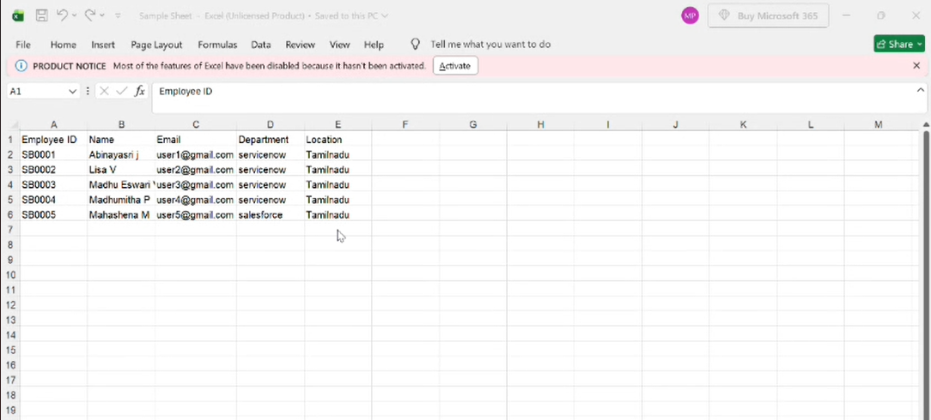

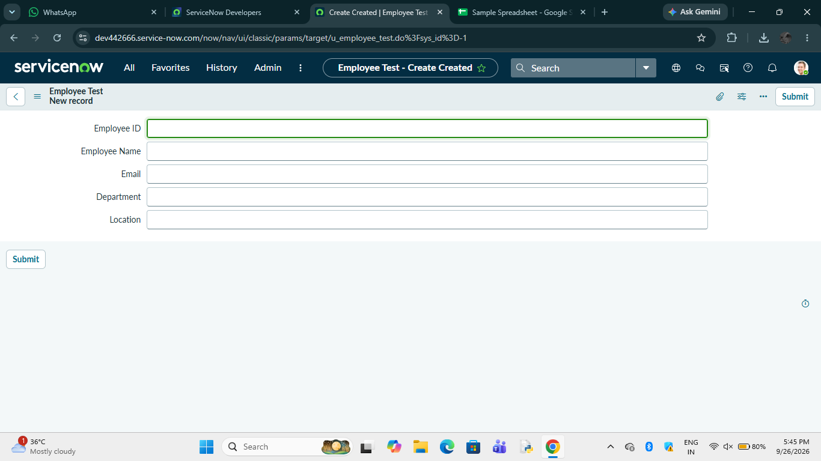

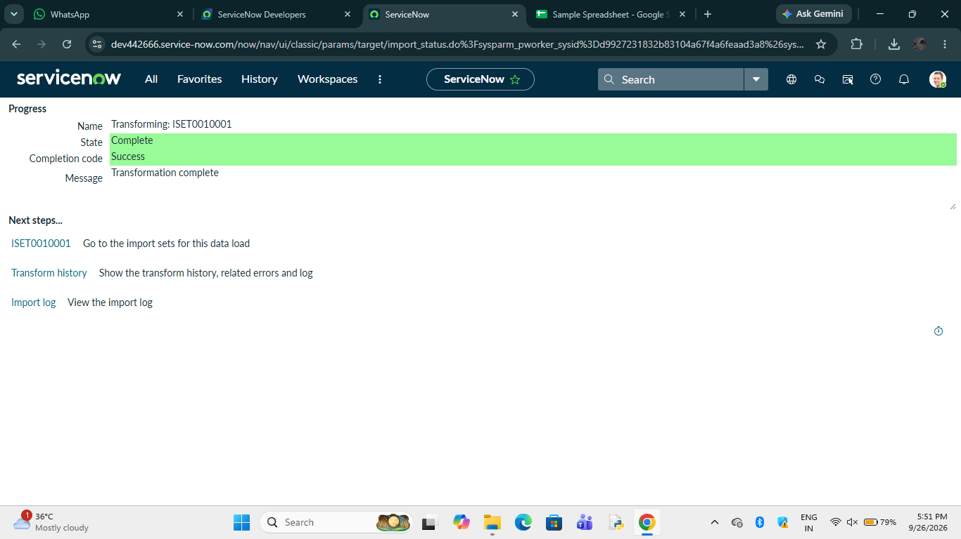

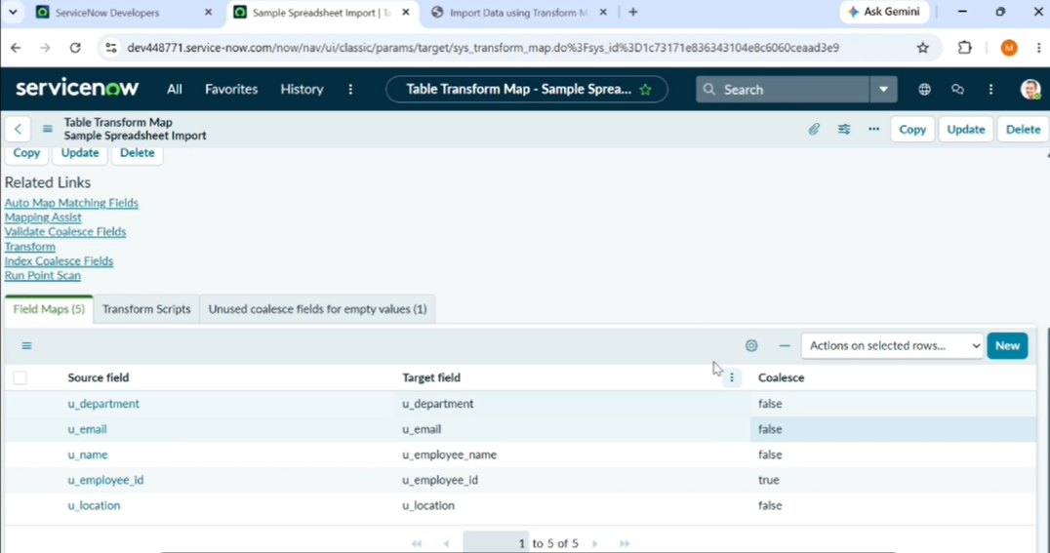

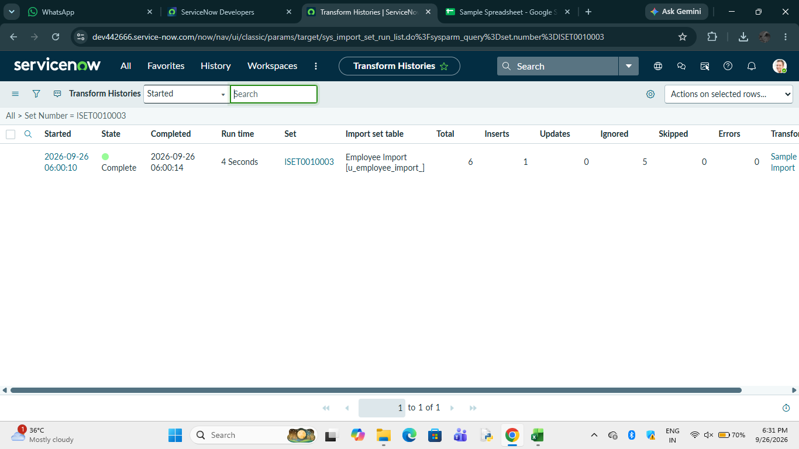

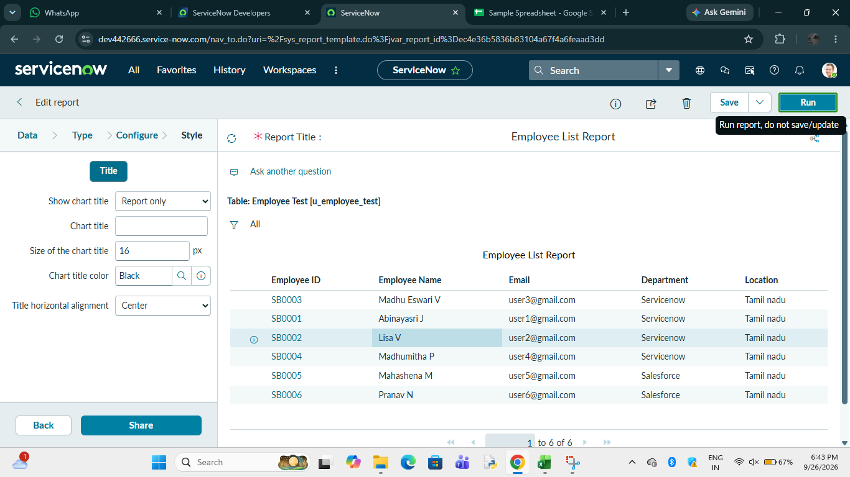

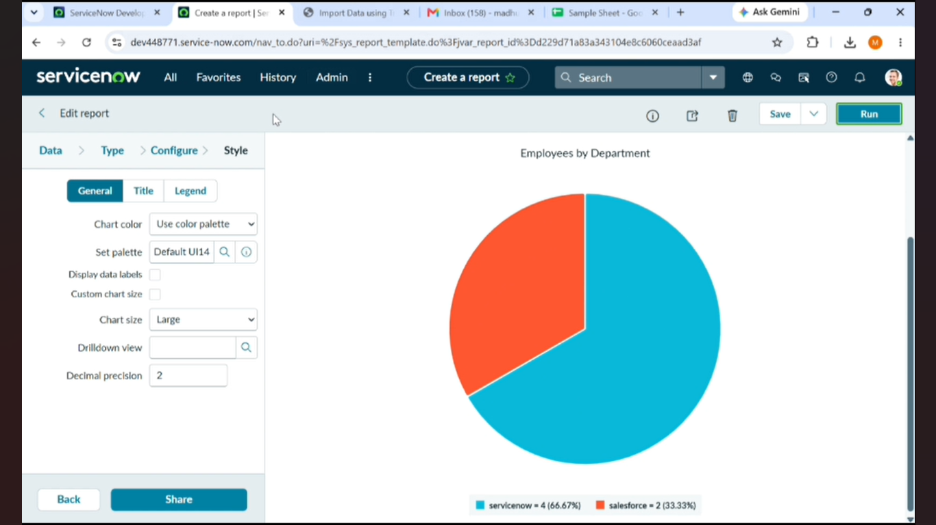

8.Advantage & Disadvantage
ADVANTAGES
- Efficient Data Import – Employee data can be imported from Excel into ServiceNow efficiently using Import Sets and Transform Maps.
- Data Accuracy – Source fields can be mapped to the appropriate target fields, helping maintain correct employee information.
- Prevents Duplicate Records – Coalesce identifies existing employee records and updates them instead of creating duplicate records.
- Easy Data Validation – Transform History helps verify whether records were inserted, updated, or ignored after the transformation.
- Automated Data Processing – The transformation process reduces the need for manually entering employee records.
- Reporting and Visualization – Reports can be created based on department, location, and employee information, and these reports can be added to a dashboard.
DISADVANTAGES
- Initial Configuration Required – Creating custom tables, Import Sets, Transform Maps, and field mappings requires proper configuration.
- Data Quality Dependency – Incorrect or incomplete spreadsheet data can affect the import and transformation process.
- Large Data Processing May Take More Time – When the volume of employee data increases, import and transformation operations may require more processing time.
- Mapping Errors – Incorrect source-to-target field mapping can result in incorrect data being stored in the target table.
- Limited Testing in the Project – The provided project demonstrates data import using a relatively small sample dataset; detailed large-scale performance testing is not documented in the source PDF.

9.CONCLUSION

The Import Data using Transform Maps project successfully demonstrates how employee data can be imported from an Excel spreadsheet into ServiceNow using Import Sets and Transform Maps. The project includes data preparation, custom table creation, data transformation, validation, and duplicate prevention using Coalesce.
The project also extends the solution with Reports and Dashboards to provide better visibility into employee data. The use of Coalesce ensures that repeated imports can update existing records instead of creating unnecessary duplicates.
Overall, the project provides an end-to-end approach for employee data migration, validation, duplicate handling, reporting, and visualization in ServiceNow.

10.FUTURE SCOPE
- Automated Scheduled Imports – Employee data imports can be scheduled automatically at regular intervals.

- Integration with External Systems – The project can be extended to receive employee data directly from HR systems or other external applications instead of manually uploading Excel files.
- Advanced Data Validation – Additional validation rules can be introduced to detect invalid email addresses, missing employee IDs, incorrect departments, and other data-quality issues.
- Error Monitoring – A dedicated error-reporting mechanism can be developed to identify and track failed imports and transformation errors.
- Performance Testing with Large Datasets – Future work can evaluate import and transformation performance using larger employee datasets and different data volumes.
- Enhanced Dashboards – More reports and visualizations can be added to monitor import status, updated records, new records, errors, and employee distribution. The current project already uses Reports and Dashboards for employee data visibility.
- Role-Based Access – Access to reports and dashboards can be further controlled based on users, groups, and roles, which is also supported in the current project.
Spreadsheet link:https://docs.google.com/spreadsheets/d/1jxQX6b-HPqbUj9YGX6GILWJW6Zi6b3nLvA-b_2DP7-8/edit?usp=sharing
Demolink:
https://drive.google.com/file/d/1muWZ_xAU9kudcFSZtDXDDyZII45nlwqh/view?usp=sharing

